Step 6: What to do instead of smoking
Come up with ideas of what you could do instead of smoking when:
- Waking up
- Bored
- Driving
- After meals
- Drinking
- On the phone
- Stressed

Step 7: Select you quit day!
I will not use tobacco on this day or any day after that!

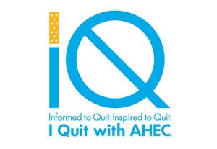

Steps to Quitting

Date of publication
Face to face counseling with Tools to Quit or Quit Smoking Now classes.

Talk to a quit coach

1-877-822-6669

Online Program

http://www.ahectobacco.com

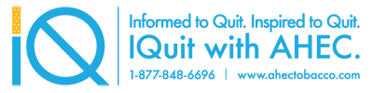

Step 1: Benefits of Quitting
What are your personal benefits to quitting smoking?

Step 2: Reasons to Quit
- Save money
- Improve health
- Improve physical performance
- Whiter teeth
- Clothes and breath smell better
- Much less chance of lung and oral caner
- Set an example for friends, family and children

Step 3: Enjoying life without Nicotene
What are some healthy activities that might also make you feel relaxed, focused, calm and steady?

- Reading
- Listening to music
- Playing with kids
- Exercising

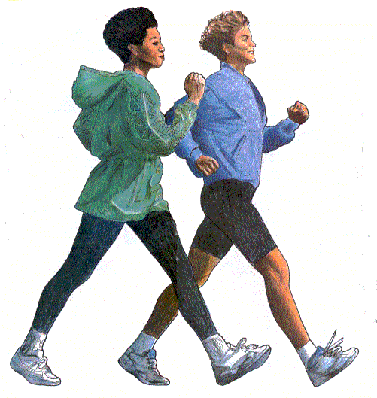

Step 4: Why do you smoke?
I crave cigarettes. What are some things I can do beat the craving?
- Use nicotine replacement therapy such as the patch or nicotine gum.
- Ask for help from family and friends
Smoking helps me relax. What are some things I can do instead?
- Use relaxation techniques
- Exercise regularly
- Take a hot bath, massage, listen to soothing music
Smoking is a habit. What can I do instead?
- Before quit day, change smoking routine.
- When you want a cigarette, wait one minute. Try to think of something else.
- Be aware of every cigarette you smoke. Do I really want this cigarette?

Step 5: Preparing for Triggers

Identify all the times that you use your tobacco.
- When I’m tired
- When I’m hungry
- When I am stressed
Company Name
Street Address
Address 2
City, ST ZIP Code
Phone (555)555-0125
Fax (555)555-0145
Web site address

