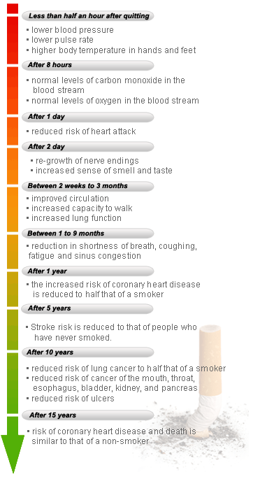



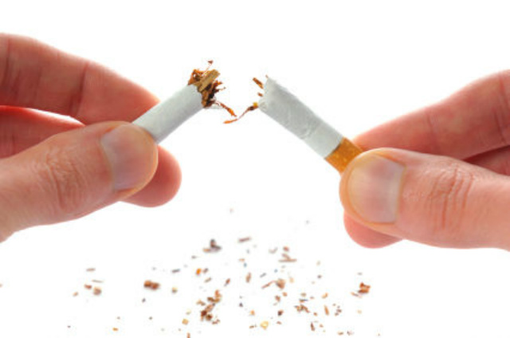

# How Smoking Affects You

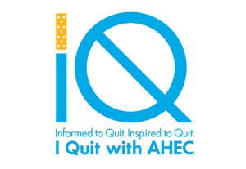

Face to face counseling with Tools to Quit or Quit Smoking Now classes.

Talk to a quit coach

1-877-822-6669

Online Program

http://www.ahectobacco.com/

logo





http://cysticfibrosis.about.com/od/livingwithcysticfibrosis/a/secondhandsmoke.htm

* Weight loss or poor weight gain
* Increased respiratory infections: Those with cystic fibrosis who are exposed to second-hand smoke suffer from more frequent and more severe lung infections than those who are not exposed to smoke.
* Decreased lung function: people with cystic fibrosis who are exposed to second-hand smoke at home have lung functions 10% lower than those with CF who are not exposed to smoke.

How does second hand smoke affect those who have Cystic Fibrosis (CF)?

Tobacco smoke contains toxic chemicals. Tar is the buildup of those chemicals. It coats the lungs and leads to diseases like chronic bronchitis and emphysema. There are also chemicals in the tar that are known to cause cancer. These are calling carcinogens. All forms of tobacco contain these cancer causing chemicals.

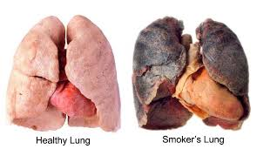

* There are over 7,000 chemicals in a lit cigarette.
* The tobacco companies add as many as 600 different ingredients, like menthol.
* The lit cigarette or cigar is very hot and the combustion also creates chemicals.
* Any amount of smoke causes harm
* Nicotine is what keeps you smoking
* Nicotine is an addictive drug and is found in the tobacco plant.

Have you ever thought about what’s in a cigarette?

